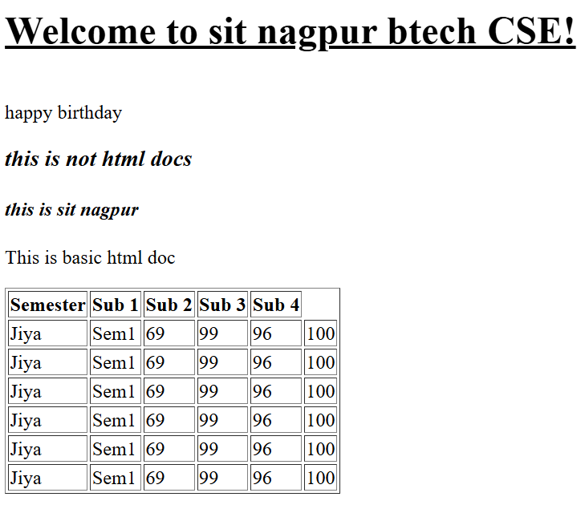
Practical: - To create a table in html
<!DOCTYPE html>
<html>
<head>
<title> Page title </title>
<body>
<h1><br><u> Welcome to sit sit nagpur btech CSE! </h1></b></u
<h2><br> happy birthday </br></h2>
<h3> <i> this is not html docs </i></h3>
<h4><i> this is sit nagpur </i></h4>
<P> This is basic html doc </P>
<table border = "1">
<tr>
<th> Semester</th>
<th> Sub 1 </th>
<th> Sub 2 </th>
<th> Sub 3 </th>
<th> Sub 4 </th>
</tr>
<tr> <td> Jiya</td> <td>Sem1</td> <td>69</td> <td>99</td> <td>96</td> <td>100</td> </tr>
<tr> <td> Jiya</td> <td>Sem1</td> <td>69</td> <td>99</td> <td>96</td> <td>100</td> </tr>
<tr> <td> Jiya</td> <td>Sem1</td> <td>69</td> <td>99</td> <td>96</td> <td>100</td> </tr>
<tr> <td> Jiya</td> <td>Sem1</td> <td>69</td> <td>99</td> <td>96</td> <td>100</td> </tr>
<tr> <td> Jiya</td> <td>Sem1</td> <td>69</td> <td>99</td> <td>96</td> <td>100</td> </tr>
<tr> <td> Jiya</td> <td>Sem1</td> <td>69</td> <td>99</td> <td>96</td> <td>100</td> </tr>
</body>
</html>

